Patient Instructions

TRI SHELL Pneumatic Walker
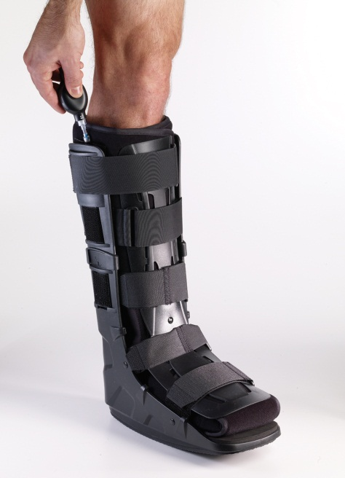

Application Instructions:

- Undo all of the velcro and remove the front plate from the boot
- Place affected leg into the boot making sure that the heel is all the way at the back
- Wrap the liner around the shin and the foot
- Place the front plate back onto the boot
- Velcro the straps starting at the bottom and working towards the top
- Add air into the air valves on the 2 sides of the boot until it feels snug
Removal:

- Air can be removed from the boot to make removal easier
- Undo the Velcro straps
- Take the front plate off
- Undo the liner and remove foot from boot
Tips:

- Men’s Sizes
  - Small up to an 8, Medium 8.5 – 11.5, Large 12+
- Women’s Sizes
  - Small up to an 8.5, Medium 9-12, Large 12.5+
- Toe’s can hang over the foot plate slightly (as long as its safe for the patent) if their calf fits into the boot nicely
- The extra pads can be added around the ankle to add more support or make the boot more comfortable for the patient
- Care Instructions: Wipe plastic shell with damp cloth, you may use disinfectant or mild soap, and wipe dry.

